Ben Parks
8/31/2026
CP 1
Idea: I would like to build an activity tracker - similar to a smart watch. I will be measuring heart rate, skin-temperature, and motion. I got an activity tracker this past year, and I have been addicted to it. I’ve had times in my life where my health has declined, and I think these trackers are a really good way to motivate yourself and stay accountable. I would love to implement a sleep tracking function, but I would have to go to sleep to truly test it, and I think that would be annoying. So that will be an add-on if I have extra time. I think this project will be interesting because I would like to make this a wearable device, and to truly make it wearable, it will require some serious effort into making the design compact and unobtrusive. I am going to have fun making this design as clean and contained as possible.
Meeting Constraints
Givens - Will incorporate BMP280 and use subfunctions for code.
Unique Raw Sensor - IR Led shining through finger to a photodiode on the other side of the finger. Measuring changes in blood volume with each heartbeat.
Non-Linearity - The RAW sensor’s nonlinear transfer function arises from Beer-Lambert light attenuation through tissue:
$$I_{light}=I_{0}⋅e^{-μ\left(blood volume\right)⋅x}$$
Where I_{o} is the LED intensity entering the finger, I_{light} is the intensity reaching the photodiode, u(v) is the absorption coefficient as a function of blood volume, and x is the path length through the tissue. I plan on using a translinear log amplifier for hardware linearization. Will use a bandpass filter with the log amplifier for the analog filter. The LED driver circuit separately exhibits diode nonlinearity, but this affects illumination consistency, not the sensor’s measurement transfer function. I will choose a current-limiting resistor to get a consistent LED brightness.
Capacitive Sensor - Finger presence detector to start measuring heart rate. Will use external signal processing. Not too worried about this after talking to past students.
Battery - Will use 9V battery and 7805 voltage regulator to step down.
Algorithms - Kalman Filter applied to Photoplethysmography (PPG) heart rate estimate. The Go Beyond algorithm will correlate to ideal heart rate / skin temp readings for someone's age when active and inactive. Will use real research. Biometric data will be logged to a free IoT platform at a consistent time interval.
Redundancy - Redundant measurement will be heart rate. Using IR light shone through finger as one branch of physics (optics), and electrical signals via sticky skin electrodes as another branch of physics. (More on this later).
Three Measurand(s) - Heartrate, Skin Temperature, Motion (Raw = Thermistor, IR LED, Photodiode | Prepackaged = Heartrate sensor (AD8232) and Accelerometer (ADXL345)
Self-Contained - 3D Printed wearable. Reasonable Size. Raspberry Pi Pico has solid documentation, was recommended in class, and has Wi-Fi capabilities to log data. Pico also has 3 ADCs for me to use.
PCB Design - Will use KiCad because of previous experience in Design.
Calibrate to Known Values - Environment temp = thermostat & BMP280, Skin temperature = my current fitness wearable, heart rate = current fitness wearable & redundant measurement, motion = distance & time movement of arm
Bill of Materials
Function | Name | Quantity | Cost
Accelerometer (Pre-packaged) | ADXL345 | 1 | $20.95
Heart Rate Sensor (Pre-packaged) | AD8232 | 1 | $24.41
Sensor Cable for Electrode Pads |  | 1 | $8.75
Electrode Pads | Kendall 200 Series | 100 | $16.11
Microcontroller | Raspberry Pi Pico 2w | 1 | $8
Battery | Energizer 9V | 4 | $10
IR LED |  | 1 | Provided
Photodiode | BPW34 | 4 | $7.28
Pressure & Temp Sensor | BMP280 | 1 | Provided
Thermistor |  | 1 | Provided
Wires |  |  | Provided
Breadboard |  |  | Provided
Circuit Components | Comparators, Op-Amps, Resistors, Capacitors, BJTs |  | Provided
Voltage Regulator | 7805 | 1 | Provided
Filament |  |  | Provided
PCB Fab | JLCPCB |  | Undetermined
 |  | Total | $95.5
Final Sensor Choices
Raw Sensor - Custom PPG (IR LED + BPW34 Photodiode). I chose the PPG model to measure heart rate because it has a well-documented nonlinear transfer function (Beer-Lambert light attenuation) and mimics real world applications. It covers one form of physics (optics), and the BPW34 photodiode is widely used, well-characterized (good datasheets), and its sensitivity aligns well to standard IR LEDs which are abundant.
Thermistor - Skin Temp. The thermistor was already provided. It is a very simple component and will be easy to integrate into a wearable - just rest it on skin.
Heart Rate Sensor - AD8232, Electrocardiogram (ECG). I was deciding between the AD8232 and the MAX30001 for my ECG sensor. I wanted to go for an ECG sensor either way to cover another branch of physics (electricity), and because it is less dependent on motion. It is a strong point of comparison because it measures the voltage signal of the heart instead of blood volume. AD8232 won because its analog output can be directly read by ADC on RasPi Pico, and its datasheet is more thorough and easy to read.
Accelerometer - ADXL345. This sensor has excellent datasheet documentation, low power draw ideal for my single-battery setup and built in event detection. I avoid the extra complexity of having to implement a gyroscope. This was the stand out option.
Capacitive Sensor – Required. Finger presence detector mentioned earlier.

Standards
While no formal standard governs my personal-built PPG/ECG wearable, there are established consumer wearable standards such as ANSI/CTA-2065 that provide a benchmark for acceptable heart rate accuracy (±5 BPM under resting conditions). Building on this, I define my own testing protocol below:
Accuracy
Measurand | Reference | Acceptable Tolerance
Heart Rate (PPG) | Commercial fitness wearable | ± 5 BPM
Heart Rate | Commercial fitness wearable | ± 3 BPM
Skin Temp | Calibrated reference thermometer | ± 1°C
Ambient Pressure | Local weather station | ± 2hPa

Required Tests
Test | Condition | Trials | Acceptance Criteria
Resting Accuracy | Seated, 2-min | 3 | 90% of readings within tolerance
Active Accuracy | Light activity | 3 | 90% of readings within tolerance
Repeatability | Same Conditions, redo | 3 | Standard Deviation < 8 BPM
Redundancy | PPG vs. ECG simultaneous reading | 3 | Difference within ± 5 BPM

These are estimates of what a standard would include for my project. It takes up more than half a page, but it uses tables and is easier to read.

3D Printing Ability
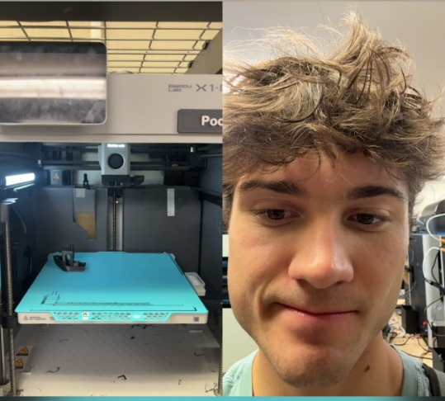
Went to ECE Lab to print Benchy

PCB software
I will be using KiCad because of my prior experience with it in Design and the large amount of documentation on it. After installing KiCad, I reviewed the official Getting Started in KiCad page online - and looked through the “Basic Concepts and Workflow” documentation.

This week
I learned that it is much more cost efficient to build these sensor projects than I realized. I know medical grade equipment has more redundancy and less error, but I still find it so cool that I am going to build a redundant heart monitor and activity tracker for under $100. I also learned the difference between a Sensor, a Sensitive Element and a Transducer. For some reason I had never taken the extra time to realize every sensor relies on some fundamental form of physics, and I find it so intriguing these tiny physical reactions are happening on these boards all the time. Breaking it down to the Sensitive Element helped me understand the base of all of our sensors on a much deeper level.
Interaction with AI
I used AI to see if my project met the course requirements and also used it as an initial research tool to see what sensors could accomplish my goals. I used it to summarize the standards and review the main components of them as well.

